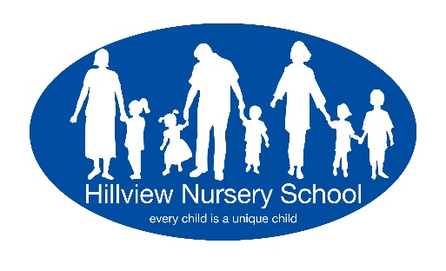
30 Hours Free Childcare - Eligibility Check Consent Form

Name of Provider Hillview Nursery School

Provider Postcode HA2 0LW

To be completed by the Claimant (child's parent/carer). Please use BLOCK CAPITALS .
Full Name of Claimant (Parent/Carer i.e. applicant in whose name the Eligibility Code was authorisecf) |  | -
National Insurance Number of Claimant
30 hours Eligibility Code  (11 digit code starting with 5000, temporary codes start with 11) | f

Child's full legal name
Child's Date of Birth

- I confirm that the above information is correct.
- I confirm that I have read the information on this form.
- I consent to the Provider named above and Harrow Council using this information to verify my eligibility for the extended entitlement of 30 hours and that the Provider will be notified of the result of the check.
- I understand that the result of the check will only be disclosed to myself, my provider and Harrow Council.
- I understand that the information will be held electronically.
- I understand that if I am eligible, Harrow Council will continue to check my eligibility and if they are notified that I am no longer eligible, they will inform my provider.
- I understand that if I am no longer eligible, I will have to pay for any additional hours above the universal Early Years Entitlement after the Grace Period has expired.

Signature of parent/carer
Name (please print)
Date

